PRESENTATION BY NTO ANNA MPAHLENI

**BRIGHT COFFEE SQL PROJECT DOCUMENT**

Contents

Objective 2

Methodology 3

➔ Checking the completeness of the data 4

➔ Processing and Data transformation 4

Insights………………………………………………………………………………………….…………………5

## Objective

Sales data analyzed across time, products, categories, and store locations

• Key patterns identified to inform strategic decisions

• Actionable recommendations proposed to boost performance

## Tools Used

Excel

Snowflake SQL

## Methodology

### Checking the completeness of the data in Excel.

Checked the number of records, on excel and saved it into an Csv file before uploading the data on snowflake

### Processing and Data transformation

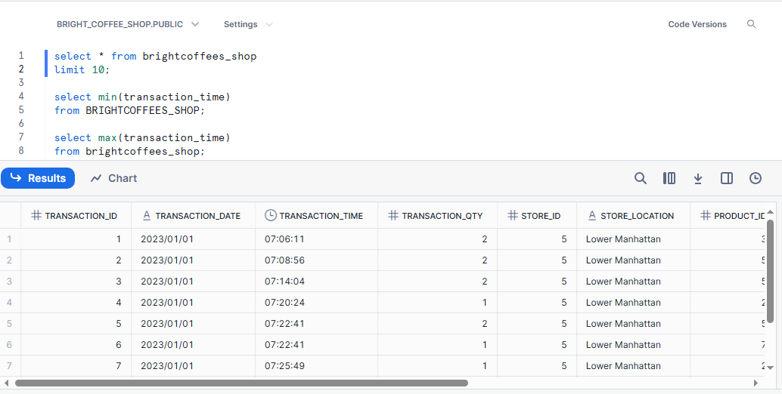

1.Selected the database table to check the column names and familiarize myself with the data.

2. Checked the minimum time of the transaction time. Which was 6:00am.

3. Selected the maximum time of the transaction time.

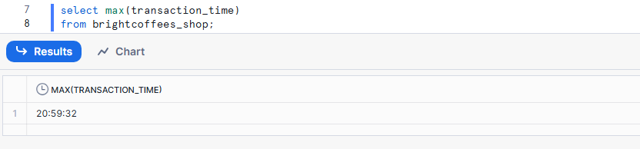

4. Created time buckets of Morning, Afternoon and Evening with the transaction time.

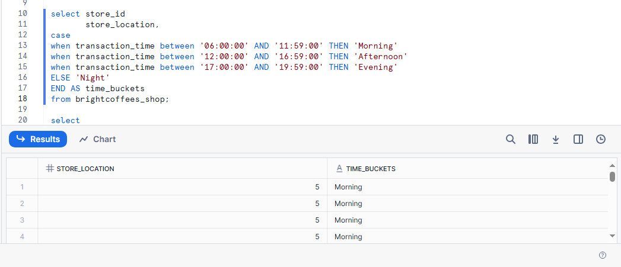

5. Calculated the total quantity sold and total sales in descending order, limited the columns to ten. Earl grey regular has the highest sales. Most of the sales come from coffee, while dark chocolate is at number 2.

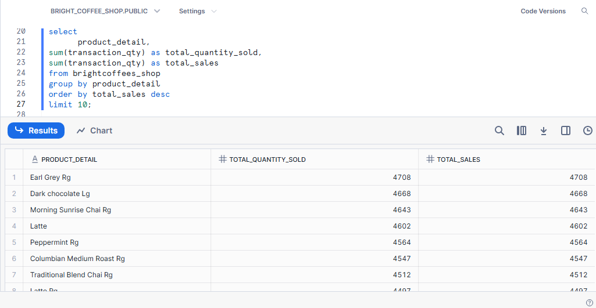

6.Counted number of sales and unique products sold. Lower Manhattan had 3 distinct products that were consistent,which were coffee,tea, and drinking chocolate.

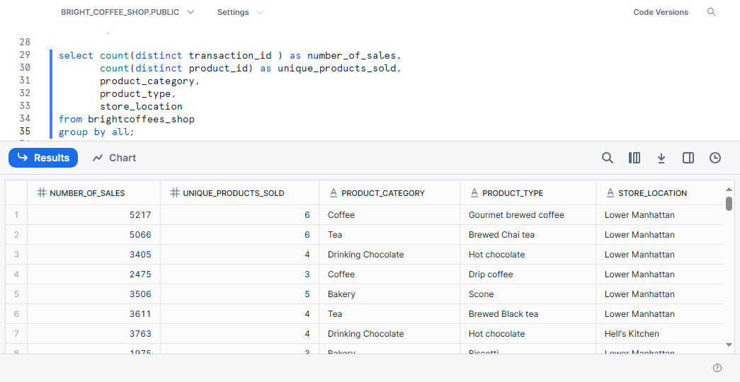

## Insights

* Total number of transactions: High volume indicating steady customer flow

• Total units sold: Suggests consistent demand for core product

• Clear monthly trends with potential seasonal variation

* Top revenue-generating months: Typically correlate with holidays or promotions
* Highest-earning categories: Likely beverages and baked goods

A few products generate the majority of sales (e.g., top 5 products)

* Busiest hours: Morning (7–9 AM) and lunch (12–2 PM)

• Slow periods: Mid-afternoon and evening hours

Top-performing stores are likely in high-traffic or well-managed areas

• Underperformers may need operational review or support